Chapter 19, Solution 48.

- Refer to the circuit below.
+
−
[ T ]
I₁
I₂
+
V₂
−
V₁
Z_{L}

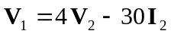 (1)
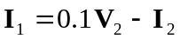 (2)

When the output terminals are shorted, 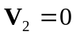.
So, (1) and (2) become
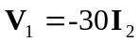 and 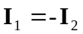

Hence,
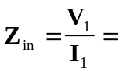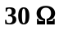

- When the output terminals are open-circuited, 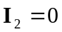.
So, (1) and (2) become
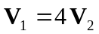
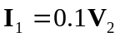 or 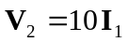

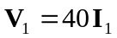

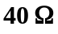

- When the output port is terminated by a 10- load, 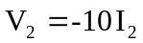.
So, (1) and (2) become
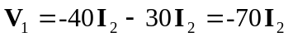
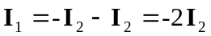

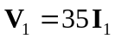

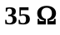

Alternatively, we may use 